IMPLEMENTATION STEP 6

IMPLEMENTING THE ENTREPRENEURIAL STRATEGY

In the previous steps, we investigated an opportunity and began to set up an enterprise and acquire the resources to exploit it. Here we continue with the implementation stage of a new venture, by considering how you manage the resources that you have acquired to build ‘competencies’ and give you ‘competitive advantage’ over other firms. We do this in relation to three aspects of the entrepreneurial strategy:

- The operations strategy
- The marketing strategy
- The financial strategy

The entrepreneurial operations strategy

An entrepreneur must be able to set up the operation so as to deliver the product or service to the right customer at the right time, cost and quality – in other words to build the operation to create value. For this it is essential that you gather the right kind of resources to begin with.

Value is created when you can build competencies and capabilities using particular kinds of resources:

- Resources that are not easily copied
- Resources that are scarce (other people don’t have them)
- Resources that are in demand (people have a use for them)

Do you have these kinds of resources in your new venture?

What makes a resource valuable?
Resource value
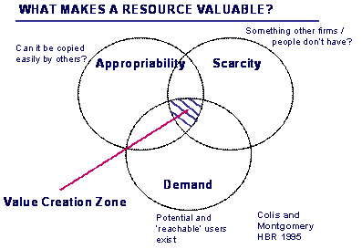

Business case link
Any business has to manage operations if it is to function efficiently. Making sure that everything happens on time and that resources are not being wasted can be a difficult task. See how the Harlequin’s Rugby Club adopted new technology to ensure no beer was wasted in their bars! To read the case click here.

It is also essential that you understand the workings of the industry value chain you will be operating in. An example of an industry value chain for the music industry is shown below:
Music industry value chain
Example Industry value chain: the music industry
The ‘music industry’ can be seen to encompass all activities and businesses that have music as product. This all-embracing definition of the music industry is as diverse as the music composed, performed and recorded. It includes the creators, developers, packagers, marketeers, distributors and advisors, who together add value to the music product on its journey to the end-user - the consumer. A value chain can usefully be employed to get a sense of how value is created, from the idea for the song in the first place (e.g. Sting woke up one night and went down to his piano and wrote ‘Every breath you take’ in a matter of minutes) through to customers actually listening to the track through a variety of media (including CDs, MP3s or streamed audio files). See the figure below for a graphical portrayal of the industry value chain.

The value chain of the music industry (sound carriers and performance)

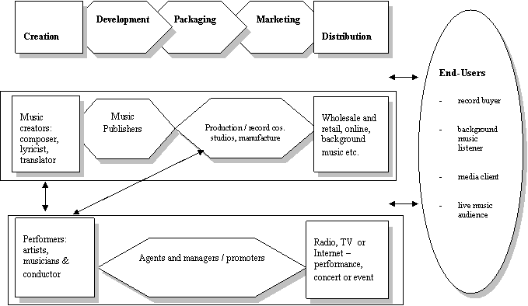

 Activity

Can you sketch out your own industry value chain?

One of the key criteria that investors look for when deciding whether or not to invest in your business is the nature of your connections with people in all key areas of your value chain. If you don’t already have good connections, now is the time to start networking.

Entrepreneurial networking

Networking by owner-managers is the all-important act of developing and maintaining contacts for trading and business development purposes. There are, of course, many different stakeholders that small business owners network with.

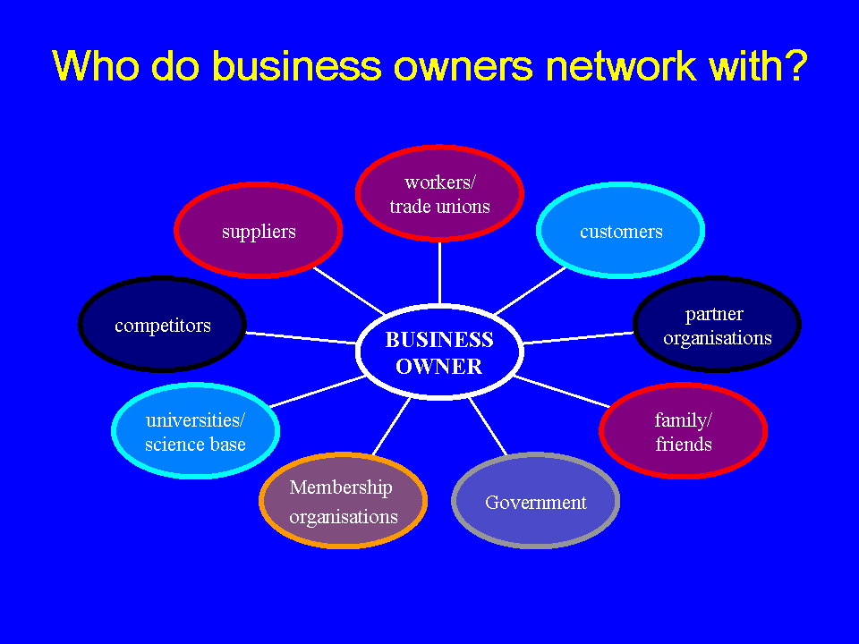

<question textentry1>
<title>Who is missing?</title>
<text>Which group of stakeholders is missing from this picture?</text>

<feedback>Investors / bankers</feedback>
</question>
Who is missing?

Research has highlighted the benefits of mixing so-called ‘strong ties’ (i.e. with family and friends and others known personally) with ‘weak’ ties (i.e. people known through others). Good networking is key in many areas of the new venture process – including helping to identify the opportunity in the first place and enabling innovation (see Steps 2 and 3); helping to leverage resources (see Step 4); and helping in the implementation of entrepreneurial strategy (this Step 5).

Activity

List the names of your family and friends – and then add to each person another friend, acquaintance or associate that you have met through them.

Now list the professions, experience, industries, interests, hobbies, networks etc that each person has.

Your entrepreneurial marketing strategy

Nowhere is networking more important than when it comes to successful relationships with your customers. Most small businesses rely heavily on word-of-mouth marketing. Getting other people to talk positively about your enterprise is an aim all businesses should aspire to. But how do you do this?

What is marketing all about in the first place?

Getting your marketing strategy right is vital to the success of your business. The DTI Business Link guide, Sales & marketing: the basics, provides a useful introduction on how to establish successful sales and marketing methods and policies. It also provides an overview and further links to the more detailed Business Link guides to sales and marketing. To access Sales & marketing: the basics click here.

How to build an effective marketing strategy for your own enterprise

Creating a marketing strategy that means you are able to satisfy your customers’ needs better than your competitors will allow you to build customer loyalty and improve sales. It is also important to monitor the competitive environment and stay in-tune with customer needs. Be alert for threats and opportunities. Identifying new markets could also form a core part of your marketing strategy.

The DTI Business Link guide Create your marketing strategy is designed to help you identify which customers to focus on and your key objectives in reaching them. It explains what to include in your marketing strategy and how it can be used as the basis for effective action. To access Create your marketing strategy click here.

Your attention is particularly drawn to the tips and pitfalls outlined! (You can also access these by clicking here.)

Tips
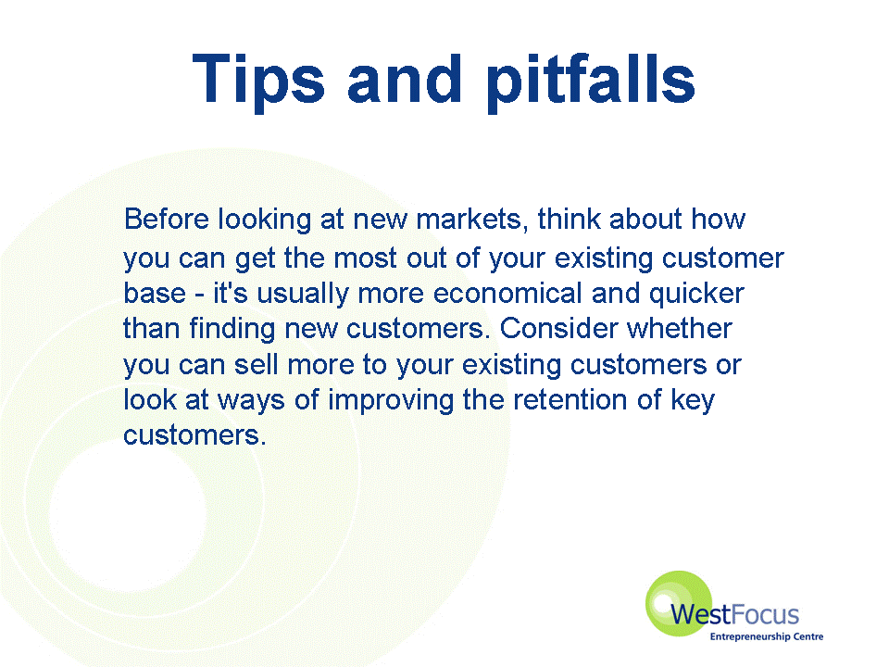
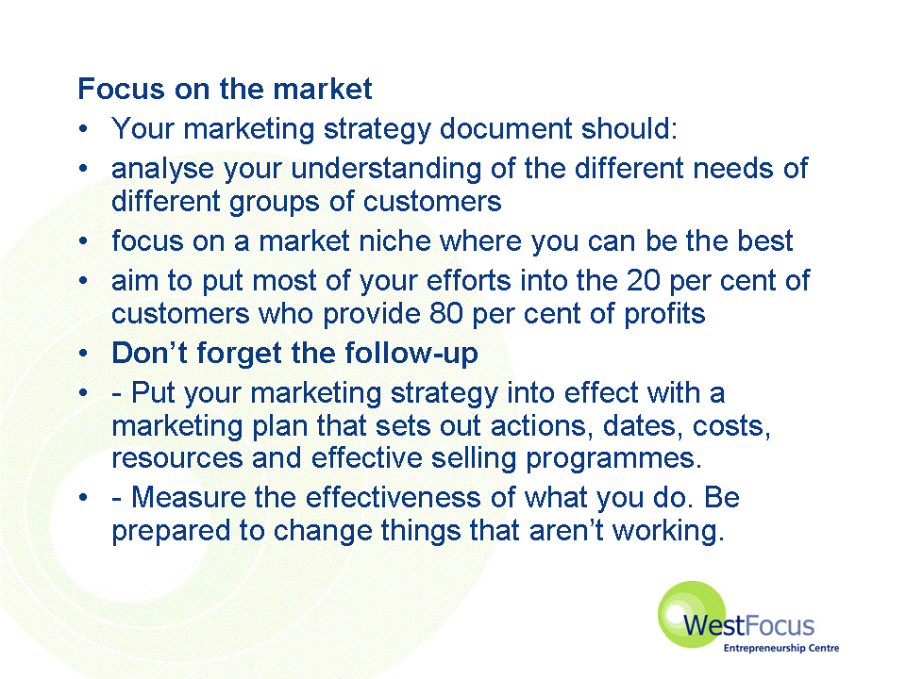
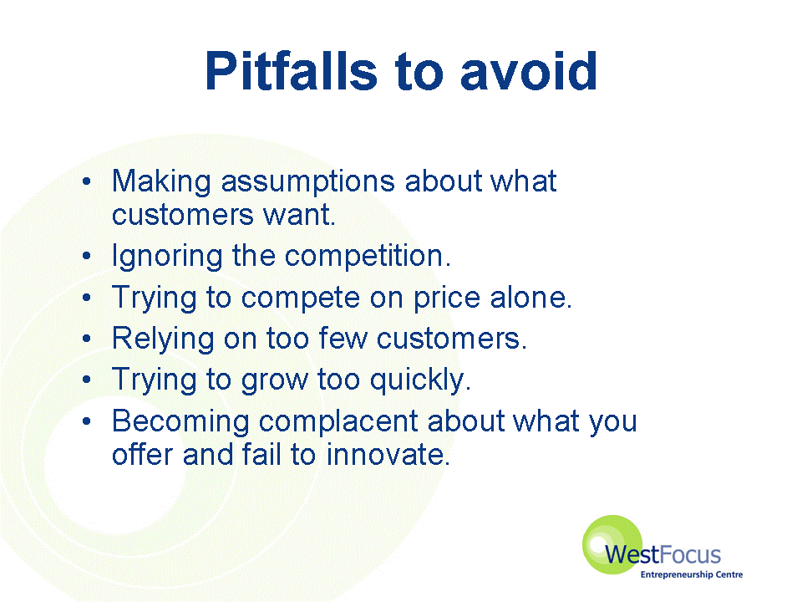

For advice on how to develop your marketing strategy see Smarta.com by clicking here. Startups.co.uk also have useful guides on marketing and PR that you can use by clicking here

If your business is going to operate online, as opposed to the traditional bricks-and-mortar approach, more details of online marketing can be obtained by clicking here.

Business case link

The case of the People’s Web illustrates the issues around price setting. Businesses work hard to set prices which cover costs, provide a profit and customers are happy to pay. To read the case click here.

But for the People’s Web pricing is only part of the issue – the competition is tough. To read more click here.

A warning to the entrepreneur

Very often entrepreneurs set up new businesses based on particular new venture ideas that they have long been interested in or have a passion about. Many involved in the music or film industries, for example, are passionate advocates for their art form. In itself, of course, this is one compelling aspect that makes up their colourful and appealing personality. However, there is always a danger that individuals get so attached to their ideas for new products, services or processes that they forget to think about whether there is a market for them. Under these circumstances there is more of a product-focus than a market-focus. This can be a dangerous strategy for the nascent entrepreneur, since without customers there will be no business through which to sell any products.

Typically, entrepreneurs take a bottom up approach to marketing rather than a top-down one. Although traditional marketing textbooks encourage you to segment, position and target your market, and to apply the so-called 4 Ps (product, price, place, promotion), you may find it useful to think in terms of 4Is instead.

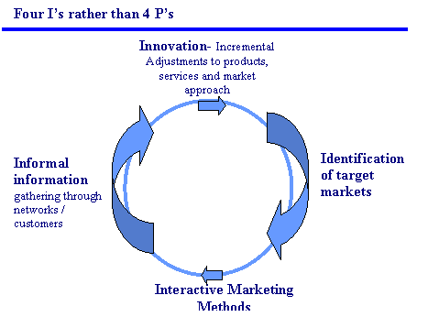

The entrepreneurial marketing sequence

The likely sequence for entrepreneurial marketing is likely to be as follows:

- an entrepreneurial venture has an innovative product which proceeds to market test to confirm the customers level of demand and requirements
- personal selling and use of networking enables informal information gathering and feedback
- this is ‘bottom up’ marketing rather than ‘top down’ which is commonly encountered in larger organisations
- there comes a time, however, when the reliance on the personal selling of the MD restricts the growth of the organisation and a transition needs to be made.

Entrepreneurs and entrepreneurial ventures, big and small, do need to be proactive in the same way in seeking opportunities by perpetually scanning their environment organisations.

A related issue then becomes how to communicate enthusiasm in the most effective manner – to all your business’s stakeholders. In Step 7 you will have the opportunity of compiling your own business plan. It will be important here to balance an appropriate level of sales ‘spin’ with the presentation of a solid and well-informed business case. Central to your plan will be your so-called ‘elevator pitch’.

What is an ‘elevator pitch’?
elevator pitch
An ‘elevator pitch’ is a term given to the crystallisation of the core selling messages into a concise, carefully planned, and well-practiced description about your company that anyone should be able to understand in a few minutes, also known as the ‘Value Proposition’ or even the ‘Guinness Pitch & Pour ‘

What an elevator pitch is not:
It is not a ‘sales pitch.’ Don't get caught up in using the entire pitch to tell the investor how great your product or service is. The investor is ‘buying’ the business, not the product. Tell him/her how you will run the business.

For some tips on creating a strong ‘elevator pitch’ take a look at this short presentation by clicking here.
Elevator presentation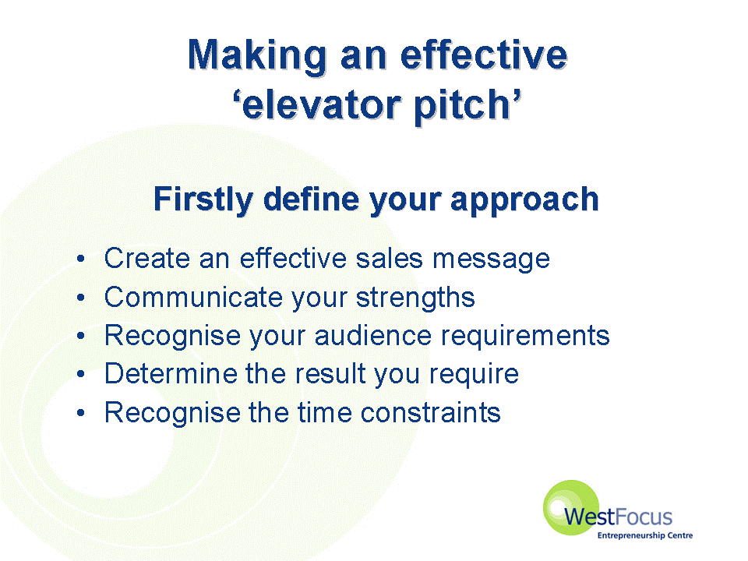

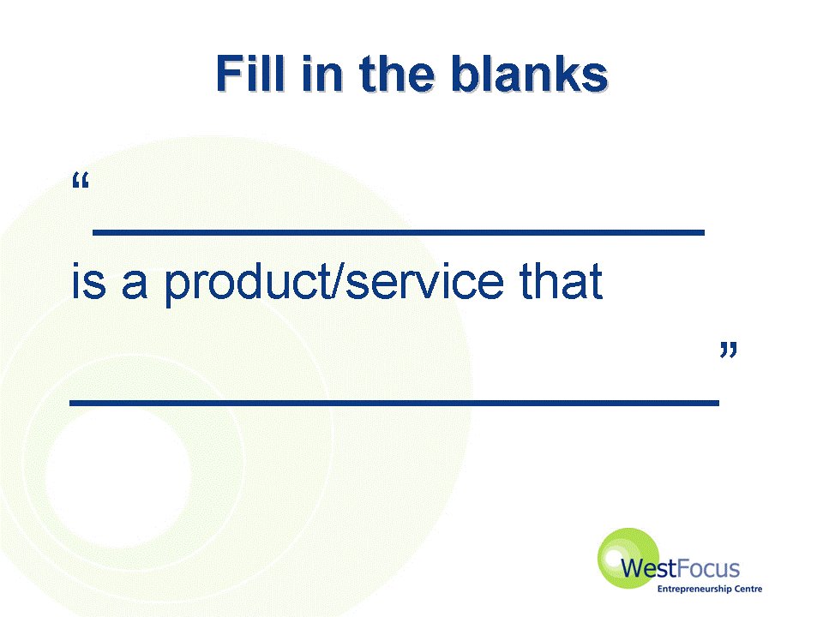
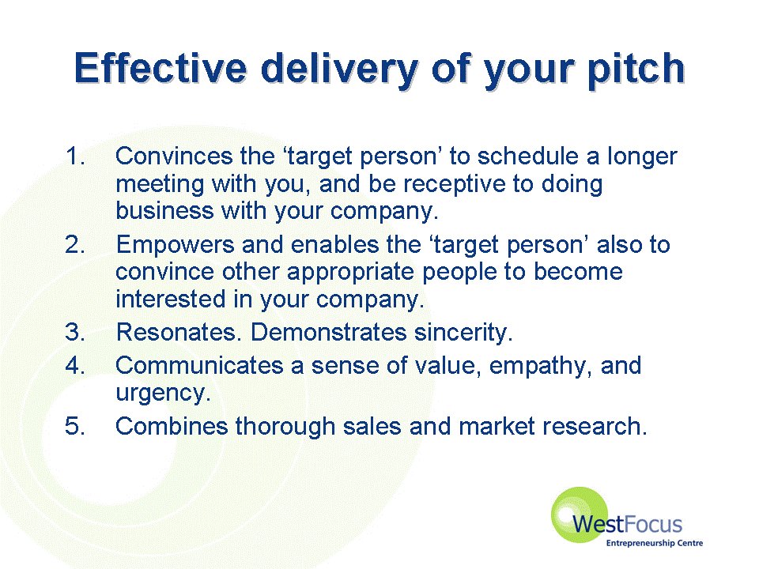
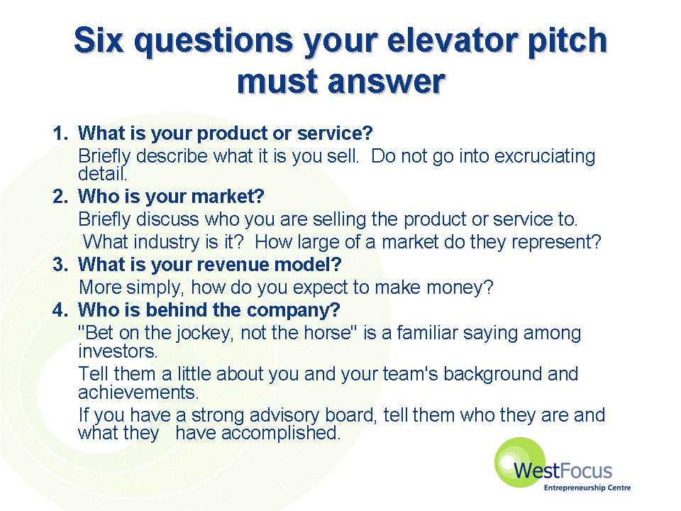
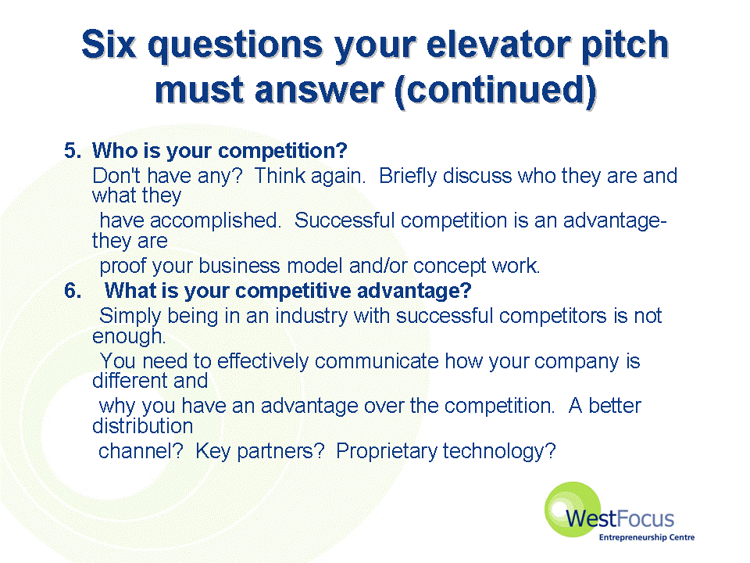
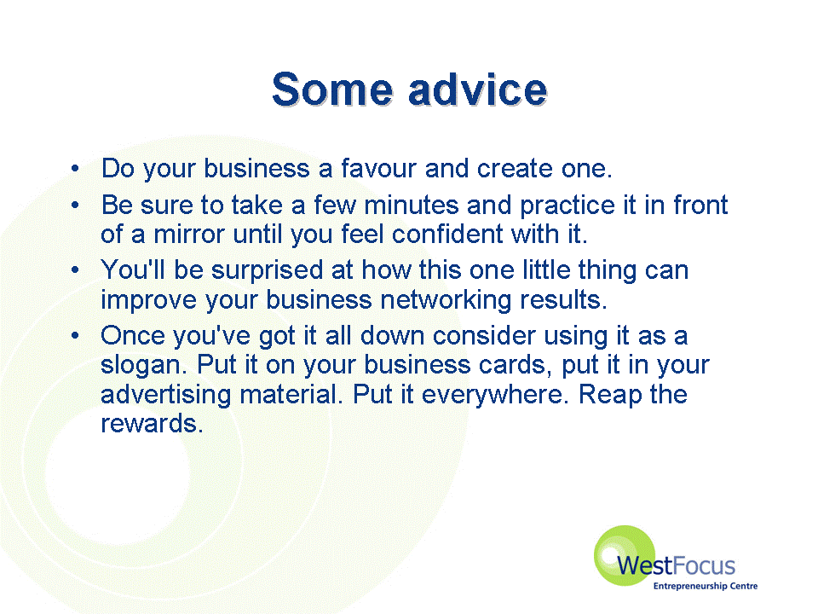

Your entrepreneurial finance strategy

It is important to stress the fundamental link between the entrepreneur’s marketing strategy and the finance strategy. Too often, business plans show wonderful figures indicating healthy financial sales and profits, but do little to justify these in terms of marketing evidence.

Two useful guides are as follows:

- SBS No-Nonsense Guide to Small Business Funding

- SBS No-Nonsense Guide to Finance for High Growth Companies

In Step 4 we looked in some detail at sources of finance and how to access the appropriate capital you require for your new venture. Our focus in this section is on how to manage the finances of the enterprise, once established. The key area to focus on first is cash-flow.

Managing cash flow

In the pursuit of value creation, there is probably no more crucial aspect of the business than managing cash flow. As the famous phrase puts it – cashflow is king!

The DTI Business Link guide Cashflow management: the basics looks at the key elements of cashflow and at how cashflow management will help protect the financial security of your business. It outlines the steps you can take when dealing with customers, suppliers and stakeholders to improve cashflow. You can access Cashflow management: the basics by clicking here.

For a more detailed look at how to identify potential cashflow problems click here.

A common problem in a rapidly expanding businesses is overtrading. This is the imbalance between the orders a business accepts and the means it has to fulfil them. The DTI Business Link has a guide that explains how overtrading can occur and shows you how to avoid the problem. To access this guide click here.

Business case link

Small businesses often complain that they are plagued by late payers and increasingly they are being caught out by customers who don't want to pay at all. For some tips on how to deal with this crippling problem click here.

For X-Tek business really started to turn around and go from strength to strength once cash flow was under control. To read the case click here.

Managing your finances

It is a vital part of the entrepreneur’s activities that they take the time to fully understand their business from a financial perspective. In the end, it is probably not good enough out-sourcing all the financial worries to your accountant or a book-keeper. Taking the time to be able to read (and interpret) your basic company accounts is indeed time well spent. Use these guides to help you in this process:

- Balance sheets: the basics
- Budgeting and business planning
- Financial and management accounts: the basics

For a full listing of the DTI Business Link Financial planning guides click here.

For detailed advice on accounts from Startups click here and from Smarta click here

Avoiding key sources of failure (4Ms)

Research suggests that new businesses are vulnerable to problems in three key areas of running the venture that can be summarised as 3Ms - Management, Marketing and Money. The best way to ensure you avoid your business becoming one of the many businesses, that fail to survive, is to think through your own strategy for the 3Ms carefully. Your integrated approach should very much be guided by the fourth M – your underlying Motivation. Be prepared, however, that as you get further into the process of setting up your new business, your own objectives and motivations may themselves change. The key is to learn from your experiences. Indeed, individual and organisation-level learning is a critical success factor for business survival and subsequent growth (discussed in more detail in Step 7).

Critical success factors (CSFs)

The following factors should improve the chances of success for your new venture:

- A niche or specialised product
- Manage your cashflow
- Minimum capital investment. It is vital to keep the company’s overheads and risk low
- Stock control - holding too much stock can tie up much needed capital.
- Quick and reliable logistics - many small businesses subcontract out their logistical services
- High visibility

e-tivity (6): Your entrepreneurial new venture strategy

You are now in a good position to reflect on your entrepreneurial new venture creation strategy.

Task 1:
In no more than 500 words, outline your integrated entrepreneurial operations strategy – how will you deliver your product or service to the right customer at the right time, at an appropriate cost and level of quality?

Task 2:
Now using a bullet point list of no more than 5 items, take each of the 3 main areas of your strategy (operations, marketing and financial) and outline the critical success factors for each, in turn.

Task 3:
What are your current strengths in relation to each strategic area? What are your weaknesses? Write these down.

Task 4:
Finally, review your own elevator pitch. How well does this reflect what you have written in Tasks 1-3. Does it need revising at all? If so, re-visit the appropriate Step for more guidance. Otherwise, continue to Step 7.

Implementation Step 6: Further links & reading

Stokes, D., Wilson, N., and Mador, M. (2010) Entrepreneurship, Cengage Learning, Chapters 11, 13 and 15.

Stokes, D. and Wilson, N. (2010) Small Business Management and Entrepreneurship edition 6, Cengage Learning, Chapters 11, 12 and 13.

M.I.T Massachusetts Institute of Technology has a strong approach to elevator pitches and provides all their information and course material free on line ocw.mit.edu/index.html

http://www.businesslink.gov.uk/bdotg/a ction/detail?type=RESOURCES&itemId=1079667915 - the challenges of growing a business and how to meet them

www.imakenews.com/techyvent/e_article000111463.cfm

www.mb-journal.com/2001_Q3/elevator.htm

techrepublic.com.com/5100-6331-5054120.html

www.businessknowhow.com/money/elevator.htm

MIT
entrepreneurship.mit.edu/Downloads/kenmorse-elevator_pitches.pdf

Project Smart - a resource for project management http://www.projectsmart.co.uk/elements-of-a-good-feasibility-study.html - article on what makes a good feasibility study

